Department of Software Engineering
Mehran University of Engineering and Technology
Shaheed Zulfiqar Ali Bhutto Campus, Khairpur Mir’s

Course: SW112 - Programming Fundamentals
Instructor | Engr. Asmatullah Zubair | PLOs | 1, 3, 4
Date | 07 November 2025 | Due Date | 28 November 2025
Batch | K25SW | Assessment Score | 10 Mark

Problem-Based Learning Activity
Developing a GUI-Based Student Record Management System in C++

Course Learning Outcome
CLO | Description | Taxonomy Level | PLO
1 | Explain and implement concepts of functions, structures, pointers in C++ | C3 | 1
2 | Use arrays and pointers to solve complex problems using arrays and pointers | C3 | 1
3 | Code, document, test and implement a well-structured, robust computer program using C++ programming language | P3 | 5

Evaluating Rubrics Level of Achievement
Components | PLO Mapping | Excellent  (4) | Good  (3) | Fair  (2) | Unsatisfactory  (1) | Score (10)
Problem recognition | 1
Organization and Structure | 3
Understanding of the Topic | 1
Argument Recommendations | 4
Learning Outcome | 4

Rubrics Description
Criteria | PLO Mapping | Excellent (4) | Good (3) | Fair (2) | Unsatisfactory (1)
Problem Recognition | 1 | Demonstrates ability to think on different kinds of problems in complicated projects and think of ways to solve them. | Demonstrates the ability to identify problems with some assistance. | Ability to anticipate the problems; however, with a great deal of assistance and unable to make or predict a proper solution. | Not able to identify any problems.
Organization & Structure | 3 | All arguments were clearly tied to an idea and organized in a tight, logical fashion. | Most arguments were clearly tied to an idea and organized in a tight, logical fashion. | All arguments were clearly tied to an idea, but the association was sometimes not clear or logical. | Arguments were not clearly tied to an idea.
Understanding of the Topic | 1 | Demonstrates an in-depth, high-level understanding of the topic and issues. | Demonstrates a good understanding of the topic and issues. | Demonstrates a low level of understanding of the topic and issues. | Fails to demonstrate an understanding of the topic and issues.
Argument | 4 | All information presented in the argument was clear, accurate, and thorough. | Most information presented in the argument was clear, accurate, and thorough. | Most information presented in the argument was clear and accurate but was not thorough. | Information had several inaccuracies or was ambiguous.
Learning Outcome | 4 | Demonstrates information that is relevant, fosters higher-level thinking, and clearly relates to the skills and content in the curriculum. | Demonstrates information that is semi-relevant, fosters higher-level thinking, and begins to relate to the skills and content in the curriculum. | Demonstrates information that is not related, displays lower-level thinking, and begins to relate to the skills and content in the curriculum. | Demonstrates information that is not relevant, discourages higher-level thinking, and fails to relate to the skills and content in the curriculum.

Problem Description

You are part of a team tasked with creating a Student Record Management System for a school. The system must allow users to add, update, and delete student records through an intuitive Graphical User Interface (GUI) built in C++. These records must be saved in a text file with data fields separated by commas for easy storage and retrieval.

Problem Scenarios
The application should include the following features:
- A form with labeled text fields to enter the following student details:
  - Name
  - Roll Number
  - Father’s Name
  - Caste
  - District
  - GPA
- Buttons for the following actions:
  - Add: Adds a new student record to the text file.
  - Update: Modifies an existing student record.
  - Delete: Removes a student record from the file.
  - Next: Navigates through the records stored in the file.
- User Interaction Scenarios:
  - When the application starts:
    - The Update and Delete buttons are disabled.
    - The Add button is enabled to allow adding the first record.
  - Clicking the Add button will save the entered details in the text file and display a confirmation message.
  - Clicking the Next button will display the next student’s record in the text fields.
    - The Add button will be disabled during this mode, and Update and Delete buttons will be enabled.
  - The Update button will modify the currently displayed student’s record using the Roll Number as a unique identifier.
  - The Delete button will remove the currently displayed student’s record from the file.
You are expected to implement the above scenarios and design the GUI to be user-friendly.
Learning Outcomes
By completing this project, you will:
- Develop skills in creating GUI applications in C++ using libraries such as Qt or FLTK or Visual Basic GUI Builder
- Understand file handling in C++ to read, write, and modify records stored in text files.
- Learn to design and implement event-driven programming through button click actions.
- Practice data validation and error handling for robust application development.
- Strengthen problem-solving and debugging abilities in a real-world scenario.
Resources

C++ GUI libraries:
- Qt Documentation: https://doc.qt.io
- FLTK Documentation: https://www.fltk.org/documents.php
Visual Basic GUI Builder (for conceptual design inspiration):
- Microsoft Docs - Create a Simple GUI with Visual Studio
Tutorials on file handling in C++:
- C++ File I/O - https://www.youtube.com/watch?v=Fvj_QNqYGmw
- C++ Read/Write csv - https://www.youtube.com/watch?v=LfiQj_X-pkA
Event-driven programming in GUI applications:
- Qt Tutorials - https://www.youtube.com/playlist?list=PLS1QulWo1RIZiBcTr5urECberTITj7gjA
Note: You are free to use any tool or resource.
Expected Outcomes
At the end of this project, you will have:
- A functional GUI-based application that meets the specified requirements.
- A well-documented codebase with clear comments and modular functions.
- Hands-on experience with GUI frameworks and file I/O in C++.
- A better understanding of implementing user interaction logic in software applications.
Here is the sample layout design for understanding

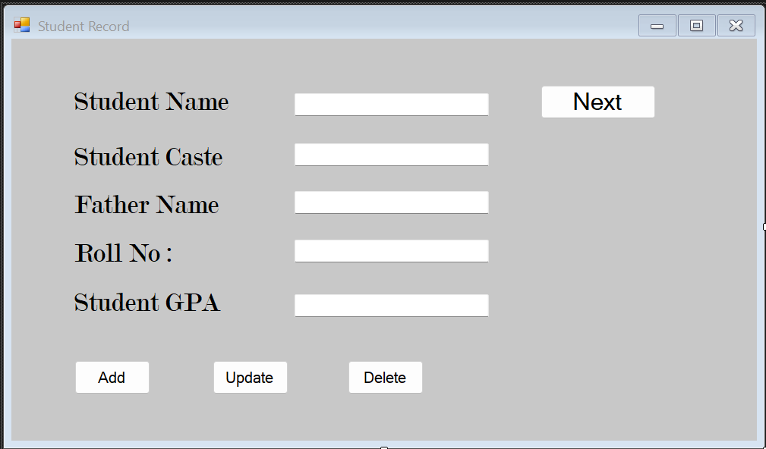

Evaluation Criteria
Your project will be assessed based on:
- Functionality:
  - Does the application allow users to add, update, delete, and navigate student records as described?
- GUI Design:
  - Is the interface user-friendly and visually appealing?
- Code Quality:
  - Is the code modular, well-commented, and follows best practices?
- File Handling:
  - Are records stored correctly in the text file and retrieved without errors?
- Creativity:
  - Have you added any additional features or enhancements to improve the application?
Deliverables

- After creating whole project, upload it on github and share link in the project report.
- Create a project report in MS Word format that explains whole project, include screen shots of GUI frames.
- Present the project or create a presentation video, upload it on G-Drive share video link in the project report.

Signature of Subject Teacher: Dated:07-11-2025

Mehran University of Engineering and Technology Shaheed Zulfiqar Ali Bhutto, Campus Khairpur Mir’s
DEPARTMENT OF SOFTWARE ENGINEERING
(SW-112) Programming Fundamentals(PF)

Project Report


Class : K25SW (1ST Semester, First Year)
Lab Instructor: Engr.Asmatullah Zubair
Submitted By: Nehel Soomro (K-25SW002)

Title of project: Student Record Management System.

Project Introduction
This Student Record Management System is a robust Graphical User Interface (GUI) application developed using Qt and C++, designed to efficiently handle student data through file-based operations. The system provides a user-friendly interface that allows authorized users to perform essential CRUD (Create, Read, Update, Delete) functionalities, including Adding new student records, Updating existing data fields, and Deleting outdated entries. Furthermore, the application includes a powerful Search feature for quick retrieval of specific records and navigation tools like Next to browse through the stored student information sequentially, ensuring organized and accessible data management.

Key Objectives
Data Organization: To create a structured method for storing student records in a file format, ensuring data integrity and ease of access.
CRUD Functionality: To enable users to perform all basic data manipulation operations:
Add (Create): Seamlessly input and save new student records.
Update: Modify and save changes to existing student records.
Delete: Permanently remove selected student records.
Efficient Retrieval: To implement a reliable Search feature that allows users to quickly locate specific student records based on various criteria.
User Experience (UX): To provide an intuitive and easy-to-use GUI (using Qt) that simplifies data entry and navigation (e.g., using Next and other controls) for the end-user.
Application Development: To gain practical experience in building a desktop application using the Qt framework and the C++ programming language.
Here are the key goals and the primary problem your Student Record Management System project addresses.

Project Goals
The main goals of the project revolve around establishing a reliable and user-friendly system for handling academic data:
Implement Core Functionality (CRUD): The primary goal is to successfully code and test all four fundamental data operations: Create (Add), Read (View/Search/Next), Update, and Delete student records using C++ file-based operations.
Enhance Usability: To develop an intuitive Graphical User Interface (GUI) using the Qt framework, ensuring that even non-technical users can easily navigate the system, input data, and perform management tasks efficiently.
Ensure Data Integrity and Persistence: To reliably save and load student data from persistent files (e.g., text files, CSV, or a basic database file) to ensure that the data remains intact and available even after the application is closed and reopened.
Improve Retrieval Speed: To implement efficient searching and navigation algorithms (like the Search and Next functions) to minimize the time required to locate and view specific student records.

Problem Statement
The project aims to solve the difficulties associated with manual, disorganized, or legacy methods of student data handling.
Inefficiency and Time Consumption: Managing student records manually (using paper files or simple spreadsheets) is time-consuming, prone to human error, and makes tasks like searching or updating slow.
Lack of Centralization: Without a dedicated system, data is often scattered, making it hard to get a comprehensive view of student information quickly.
Error Proneness: Manual data entry and modification increase the risk of transcription errors, leading to incorrect or inconsistent student records.
Poor Data Accessibility: Retrieving a specific record often requires physically sifting through documents or complex sheet filtering.
Software & Hardware Requirements:

•Programming language:CPP
• IDE: QT CREATOR

System Features / Functionalities:
•ADD Student
•Unique Roll no
•Update Student
•Search Student
•Delete Student
Project Structure
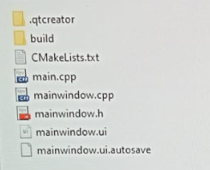
Main window.ui
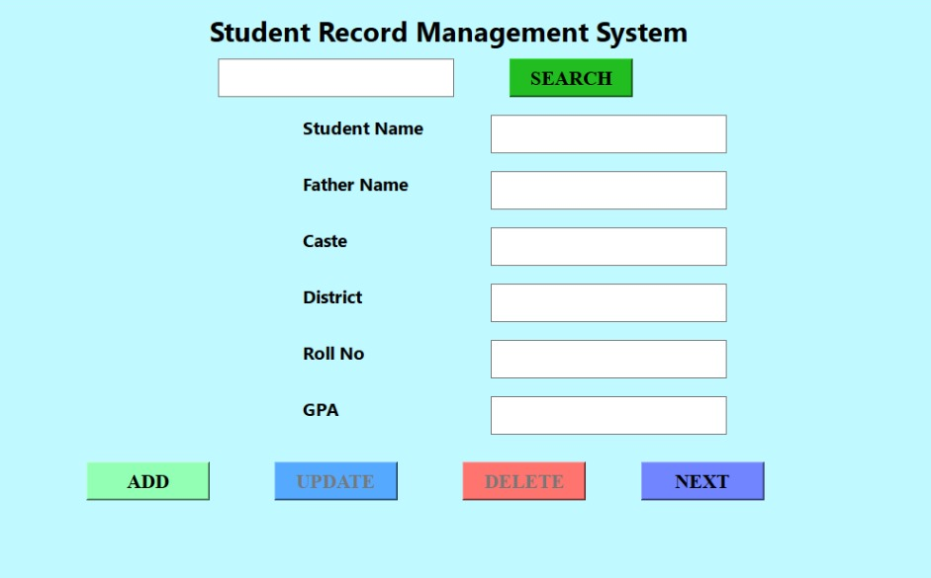
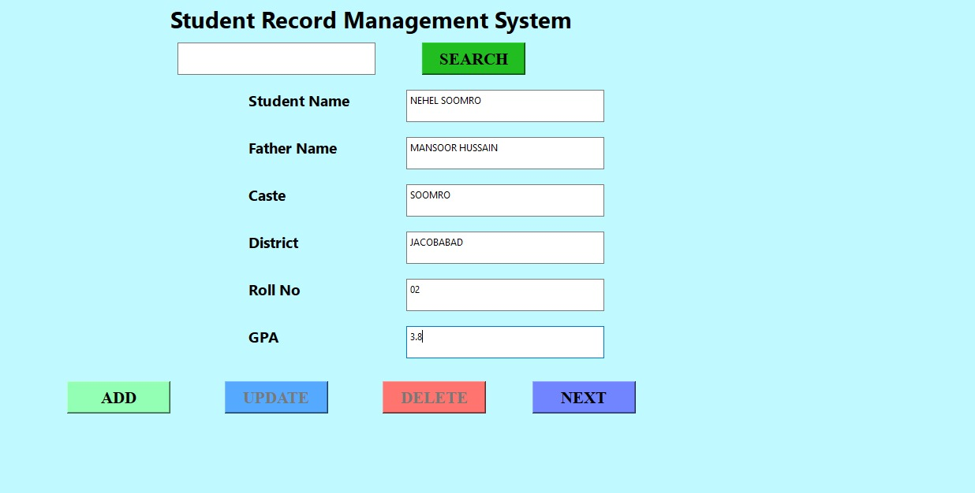
Main window.cpp
This project implements a Student Record Management System using Qt (C++) with a CSV file as persistent storage. The application provides a graphical user interface to add, view, update, delete, and search student records. Each student record includes fields for name, roll number, father’s name, caste, district, and GPA. The system ensures data integrity by validating input fields, enforcing unique roll numbers, and preventing roll number changes during updates. Records are loaded from and saved to a CSV file, with proper handling of quoted fields and commas. Navigation through records is facilitated using a "Next" button, and changes are immediately persisted. The search functionality allows users to locate students by roll number quickly, and the interface dynamically enables or disables buttons based on the current operation. Overall, the system offers a simple yet effective approach for managing student data in a lightweight, file-based environment.
Main window.h
This header file defines the MainWindow class and the Student structure for a Student Management System developed using Qt (C++). The Student structure stores key information including name, roll number, father’s name, caste, district, and GPA. The MainWindow class manages a collection of student records using a QVector, tracks the current record index, and provides helper functions to validate inputs, clear fields, escape CSV special characters, and save all records to a CSV file. It also declares slots for GUI interactions such as adding, navigating, updating, deleting, and searching student records. This design modularly separates the data structure, user interface, and functionality, enabling efficient record management and CSV-based persistence while maintaining data integrity
Main.cpp
The main.cpp file serves as the entry point for the Student Management System application. It initializes a Qt application using QApplication, creates an instance of the MainWindow class, and displays the GUI by calling show(). Finally, it starts the Qt event loop with exec(), enabling the application to respond to user interactions such as adding, updating, deleting, navigating, and searching student records. This simple but essential file ties together the user interface and backend logic, ensuring that the application runs as a standalone executable.
CMarklist.txt
The CMakeLists.txt file is used to configure and build the Student Management System project using CMake. It specifies a minimum CMake version of 3.16, sets the project name and C++ standard (C++17), and enables Qt features such as AUTOUIC, AUTOMOC, and AUTORCC. The configuration searches for Qt5 or Qt6 Widgets modules and lists all source files, including main.cpp, mainwindow.cpp, mainwindow.h, and mainwindow.ui. Depending on the Qt version and platform, it defines an executable target and links it with the Qt Widgets library. For Qt6, it finalizes the executable using qt_finalize_executable, ensuring proper integration of Qt's meta-object system. This CMake setup provides a cross-platform, automated build process, streamlining compilation and linking for the application.
Output Screenshot
.ADD OPERATION

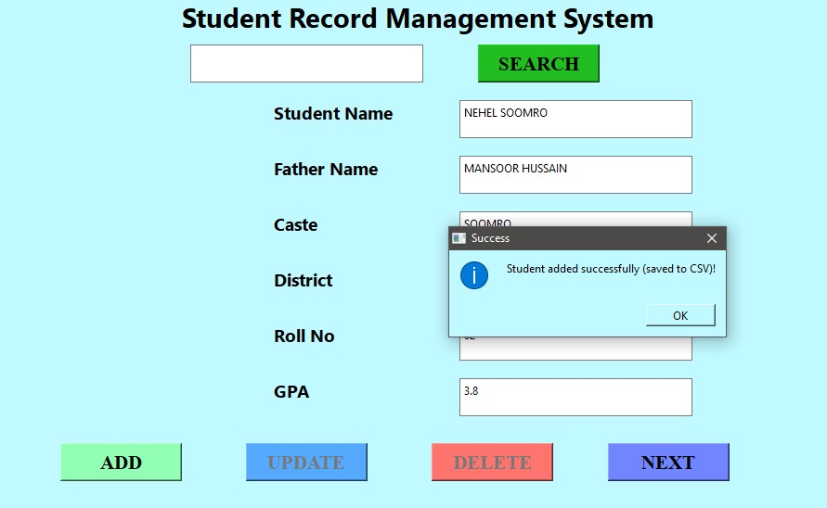

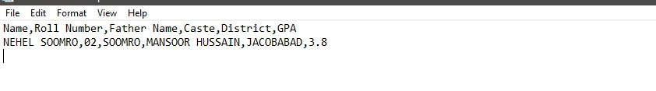

UPDATE OPERATION
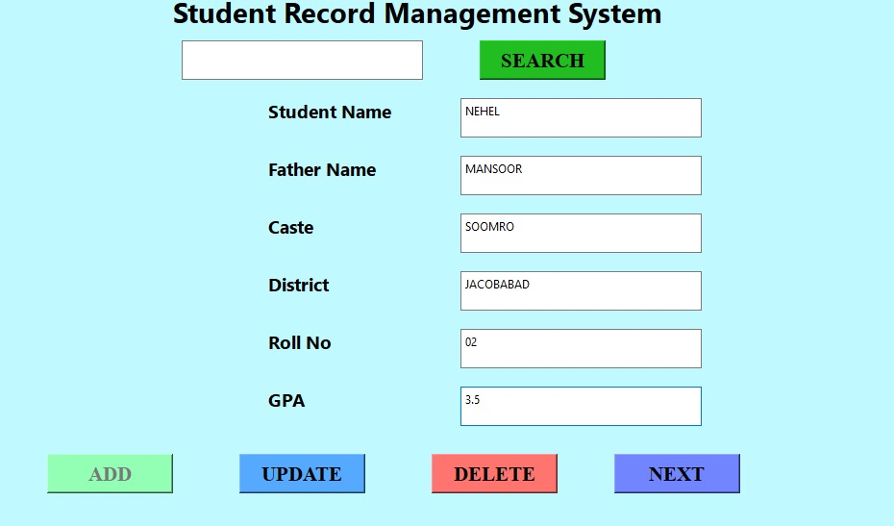
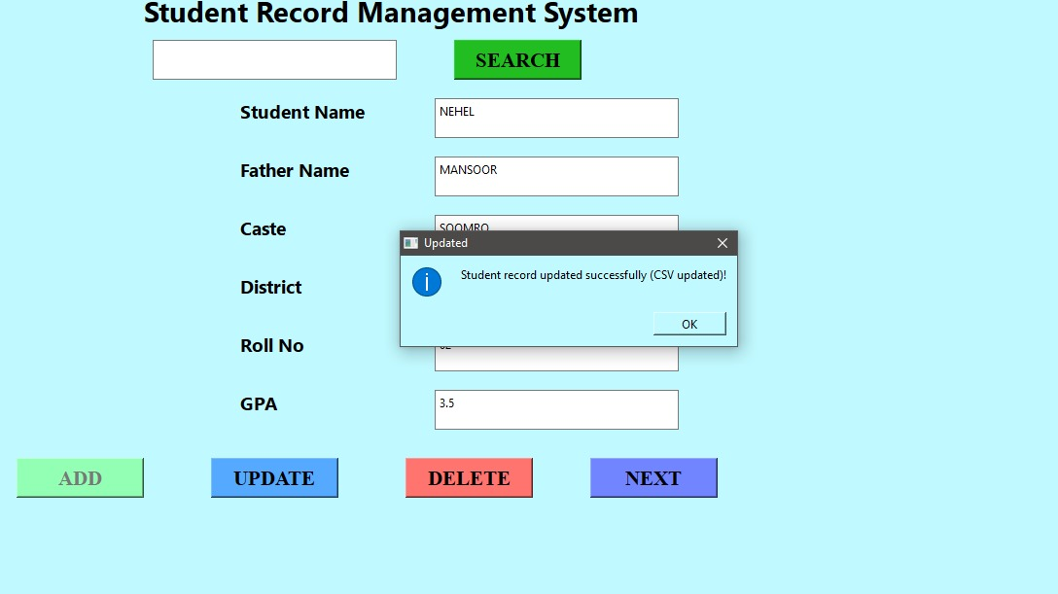
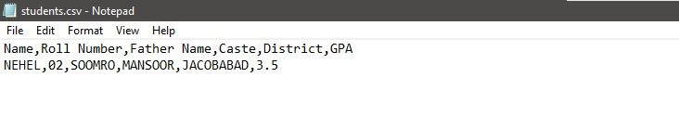SEARCH OPERATION
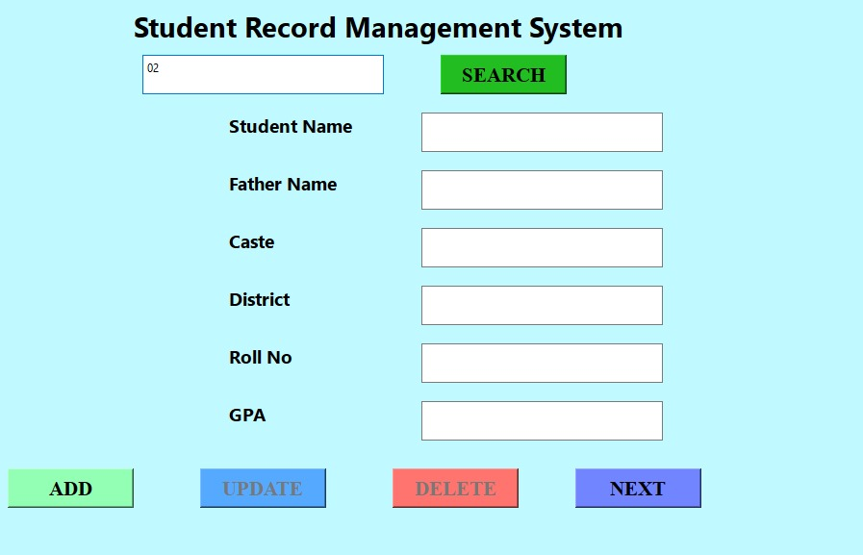
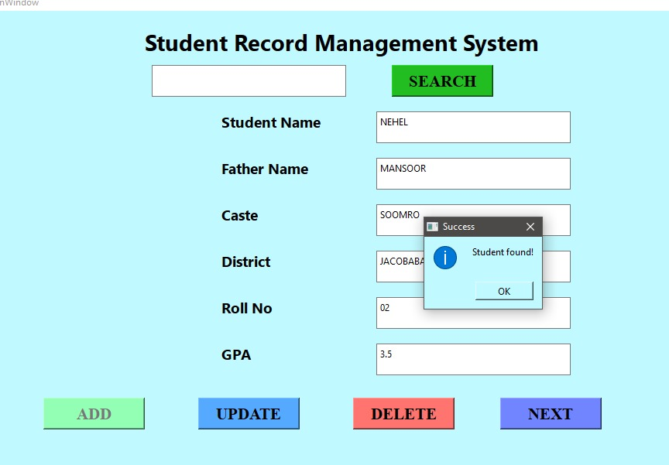
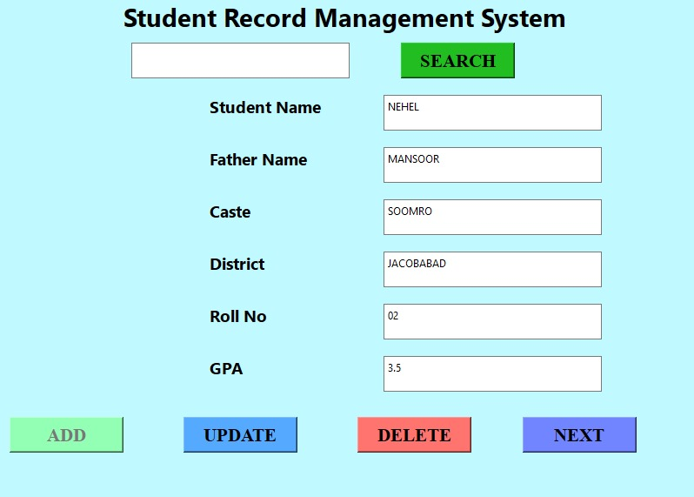
Delete OPERATION
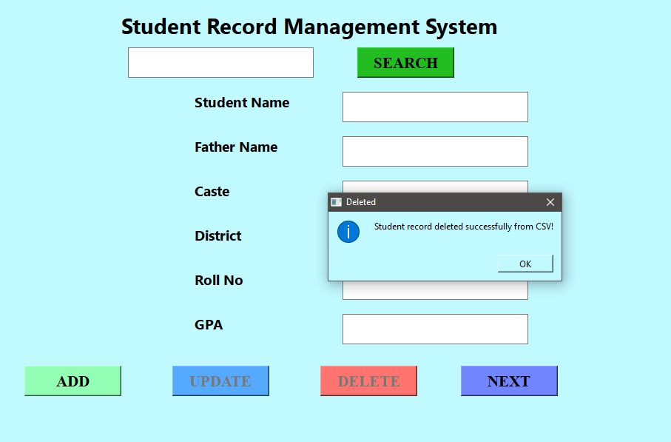

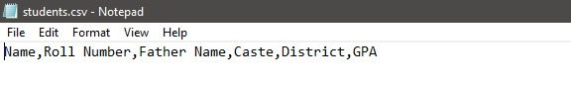

Project Conclusion
The Student Record Management System successfully demonstrates the integration of a user-friendly GUI with robust backend logic for managing student information. Using Qt (C++), the application enables users to add, update, delete, navigate, and search student records efficiently while ensuring data integrity through input validation and unique roll number enforcement. The use of CSV file storage provides a simple yet effective method for persistent data management without requiring a database. The project also highlights modular design principles, separating the user interface, data structures, and functional logic for maintainability and scalability. Overall, this system provides a lightweight, practical solution for educational institutions or small organizations needing reliable student record management, and it serves as a solid foundation for further enhancements such as database integration, reporting, or multi-user support.
GITHUB LINK: https://github.com/NehelSoomro/Student-record-management-system-1.git

